Binary Chaos
Instruction Manual
Copyright 2001 Stoic Software

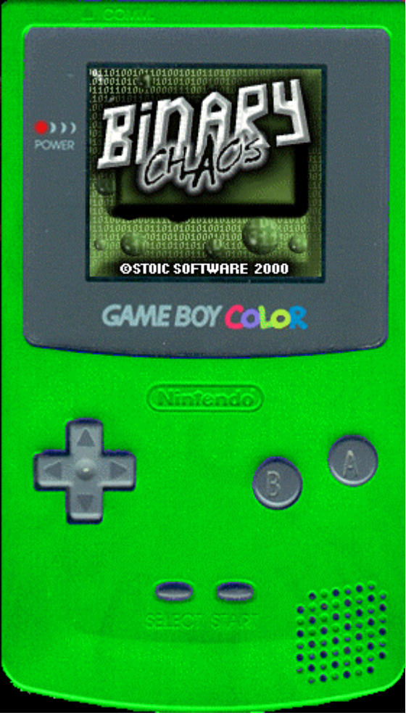

The Plot

It is the year 2050... A new type of threat has arisen to the nation: the hacker. Yet again, another hacker, this time named J.T., has compromised national security. This time, he has everything he wants at his fingertips. All he needs to do is press one key to drop a nuke on the recently formed Mars Alliance and start a full-scale war! It is up to you to save the nation by matching up all of the blocks so you have control again. Good luck!

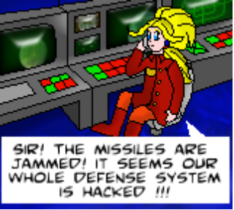

Recommended Hardware

Before beginning the game, we have a few warnings to issue.
1. This game is incompatible with all of the Monochrome GameBoys and the Super GameBoy.
2. If you need to run it under an emulator, please, PLEASE, run it under NO$GMB. Other emulators have weird graphics glitches, but even in NO$GMB, the sound sometimes seems awkward. We recommend that this game is run on a real GameBoy COLOR, NOT an emulator.

Optimal Flash Card Specs:
Size: 4Mbits or greater
Rumble: Yes (should work without one, but it takes away from gameplay)
MBC: 5 (it also works with MBC1 chips, but there is no Rumble in MBC1 Mode)
Battery: Not needed
RTC: Not needed

Starting the Game

Having said that, you are ready to play Binary Chaos! Make sure to turn off your GameBoy before inserting the cartridge. After the short Nintendo initialization sequence, the Y2KODE logo will appear, followed by the Stoic Software logo, then the Binary Chaos title screen.

Controls

+ Pad: Moves cursor
A: Confirms options, flip blocks, speeds through intro
B: speeds up stack, exits item shop
Start: Pauses/unpauses game, speeds through intro
Select: Uses item, change item (while paused)

How to Play

To begin the game, push START. An intro sequence will appear, followed by a character select screen. From here, use the joypad to select the hacker you would like to play as, then push A to confirm your selection. Another intro sequence will appear, telling you your mission briefing. For more information about the missions see the section missions. If you move around the blocks so that at least 4 of a type touch each other, they will be removed from the screen. You can move blocks by selecting two that are side-by-side with the joypad, then pressing A to confirm your selection. The game will be over if the bottom of a block on the top of the goes past the screen, and you will restart at the beginning of the level losing all of your points (not your items!). If you need to speed up the moving stack of blocks, then tap B. While B is pressed, the blocks will move up rapidly. If at any time, you need to pause the game, press START. Repeat to unpause.

After you have completed the objective of a level, another mission statement will appear, and gameplay will resume.

The Main Screen

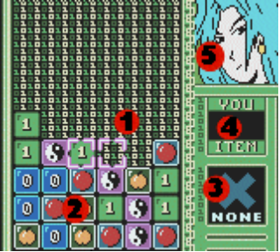

1.) Cursor – used to flip blocks
2.) Stack – continuously rises. Don’t let it get past the top.
3.) Current item – Press select to use
4.) Combo Meter – Indicates when you get a combo
5.) Character – your character

The Pause Screen

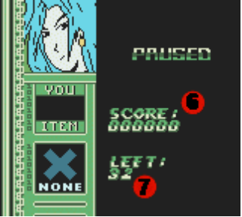

6.) Your current score
7.) Amount of the current objective left to do.

Missions

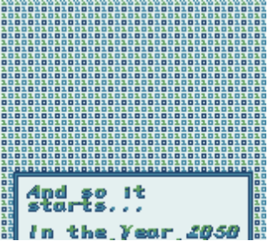

Binary Chaos is objective dependent. Before each level, you will be briefed on how to complete the current level. In case you are a slow reader or, like me, you forget what you are supposed to be doing, here.

1.) Just play around until the level ends.
2.) Get a score of 5000.
3.) Get 20 combos that are at least 5 blocks
4.) Get 10 combos that are at least 6 blocks
5.) Get 20 x2
6.) Get 1 combo that is at least 10 blocks
7.) Get 5 x3
8.) Get 1 x4

After you complete each objective, the screen will automatically fade white and you will either go on to the next level or go to the item shop. (see section on item shop)

The Item Shop

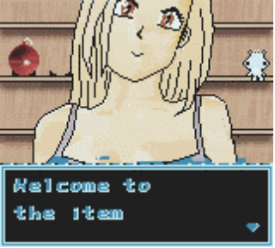

After beating a level, if you had acquired at least 5000 points, an itemshop will appear. The item shop offers three items. To select an item press up or down and then press A to buy the item. If you wish to exit the shop, press B or move your cursor to exit and press A.

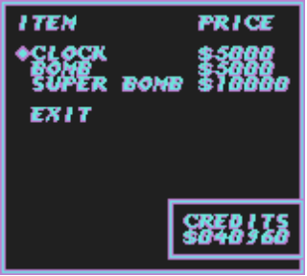

Using Items

To use an item, press SELECT. You should feel a rumble on your rumble pack. If you are using an emulator then I don’t feel sorry for you. If you have multiple items, press SELECT while the game is paused to change items.

The three items are as follows

A.) Clock. This item slows down the stack. It is more useful and noticeable in the later levels.
B.) Bomb. This item will delete all of a random group of bits. Careful! There are duds if you do not have at least one of each kind of bit on the screen!
C.) Super Bomb. This useful item will delete every block on the screen no matter how high the stack. Hint: Try using one of these on level 6.

Emulators

This game uses every bit of Gameboy hardware possible. As a result, no emulator can handle this game. If you must use an emulator, we highly recommend using NO$GMB. This can be downloaded at www.work.de/nocash. Using NO$GMB the high color images will be distorted and there will be odd hissing noises in some of the musics. Other emulators will cause all of the “Psuedo Sprites” to be black. You will not be able to read the text or see the blocks. If possible, PLEASE USE A REAL GAMEBOY! If you are a judge and you must use an emulator, please look at the folder screenshots\highcolor to view how the game should look on a real gameboy color.

Copyright and stuff

If you're stumped on a level, just keep trying... Or you can let it run out, the block combination is different each time.

The one highest rule to keep in mind, is to have fun.

If you will like to make a contribution to Stoic Software to help keep us motivated to make more free games, just buy something from the Stoic Shop. The Stoic Shop can be found at www.cafepress.com/stoicsoft If you would like to make a direct contribution, contact me at sega@world-of-nintendo.com

Nintendo, GameBoy, Gameboy, Super Gameboy, and Color Gameboy are all registered trademarks of Nintendo of America. Note since you are reading this, I’ve got a secret to tell you, hold up and press start on the press start screen will allow you access into the secret character select screen.
Binary Chaos Copyright 2000, 2001 Stoic Software.
Instruction Manual written by Joshua Wise.

